Detailed Notes on Convolutional Neural Networks (CNNs)
https://medium.com/thedeephub/convolutional-neural-networks-a-comprehensive-guide-5cc0b5eae175

1. What are Convolutional Neural Networks (CNNs)?

- Definition: Convolutional Neural Networks, also known as ConvNets or CNNs, are a special kind of neural network.
- Purpose: They are specifically designed for processing data that has an unknown grid-like topology.
- Examples of Grid-like Data:
  - Time series data (1D), where data arrives sequentially, one time step after another.
  - Images (2D), where pixels are arranged in a grid-like structure.
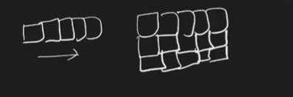
- Primary Application: CNNs are very widely used for image classification data and have a multitude of applications today. They are considered a very important topic to study.

2. Key Differences from Artificial Neural Networks (ANNs)
- Core Operation: The main distinguishing feature of a CNN is the presence of convolutional layers. These layers perform a special operation called the "convolution operation".
- ANNs vs. CNNs: In contrast, traditional ANNs use matrix multiplication for their operations.
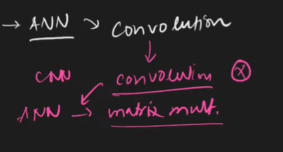
- Identification: If a neural network's architecture contains even a single convolutional layer, it is classified as a CNN.

3. Architecture and Components of a CNN
A CNN typically consists of three main types of layers:
- Convolutional Layer:
  - This is the primary layer that performs the convolution operation.
  - Its main function is to extract features from the input image.
- Pooling Layer:
  - While not detailed in the introductory video, it is mentioned as a crucial component of a CNN architecture.
  - It is typically used to reduce the spatial dimensions (width and height) of the input volume for the next convolutional layer [Source did not specify its function beyond being a layer type].
- Fully Connected Layer (FCL):
  - This layer is similar to those found in ANNs, where every node (neuron) in the layer is connected to every node in the subsequent layer.
  - The FCL usually forms the final part of the CNN, used for classification based on the features extracted by the convolutional and pooling layers.

4. Inspiration and History
- Inspiration: CNNs are heavily inspired by the human brain's visual cortex – the part of our brain responsible for sight. Computer scientists studied how the human brain processes visual information and transferred that understanding into the design of CNNs.
- 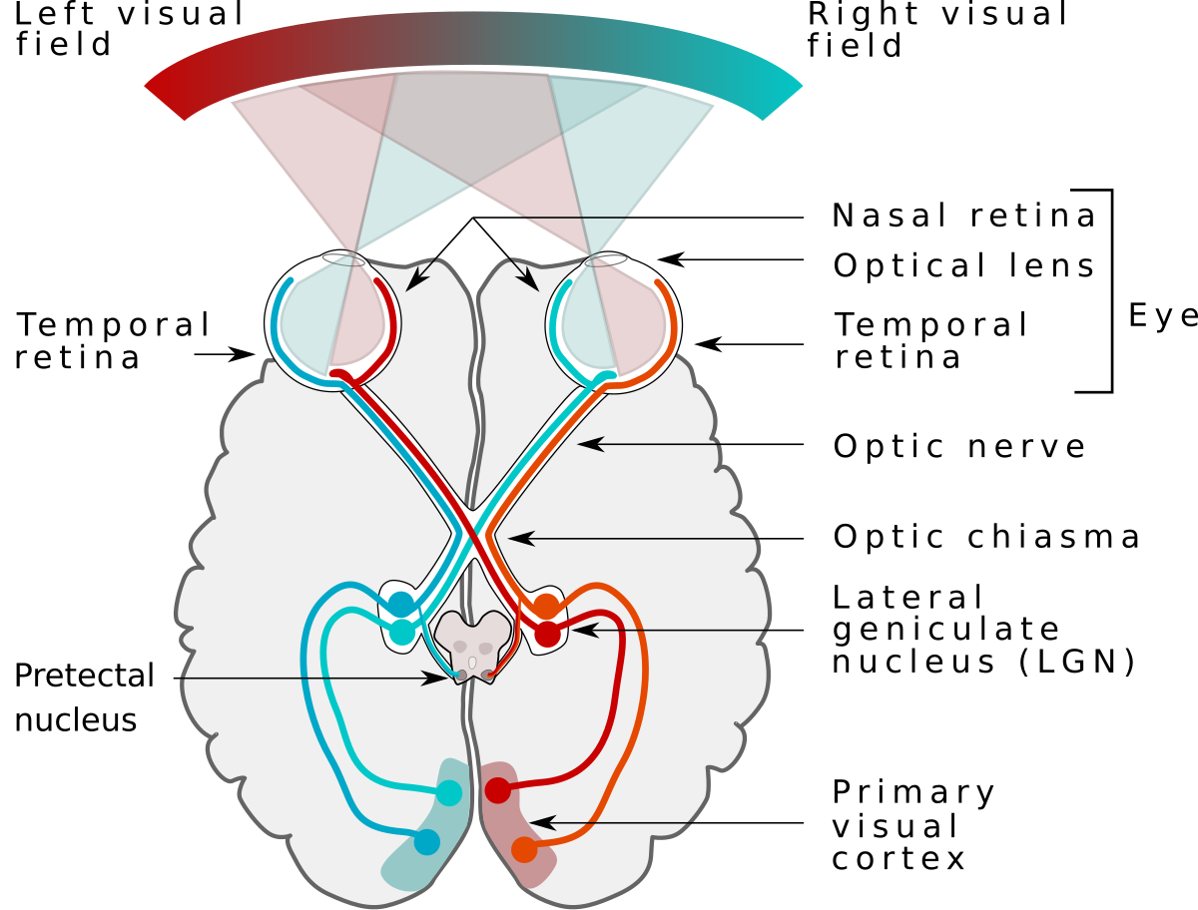
- History:
  - 1998: Yann LeCun developed the first successful convolutional network at AT&T Labs.
  - Application: This early CNN was capable of scanning checks and identifying handwritten digits.
  - Subsequent Developments: Following this, Microsoft developed various OCR (Optical Character Recognition) and handwriting recognition tools, which significantly boosted research in CNNs.
  - Modern Day: Today, CNNs are one of the most popular and successful neural networks available. They are integral to applications ranging from facial recognition software to self-driving cars. Their impact on society is profound due to their successful real-world implementations.

5. Why CNNs are Necessary (Problems with ANNs on Image Data)
While ANNs can be used for image classification (e.g., achieving about 98% accuracy on the MNIST handwritten digits dataset), CNNs consistently perform better. The primary reasons why ANNs are not ideal for image data are:
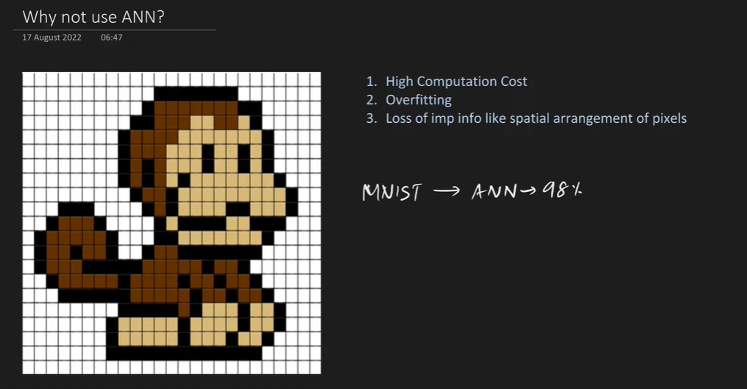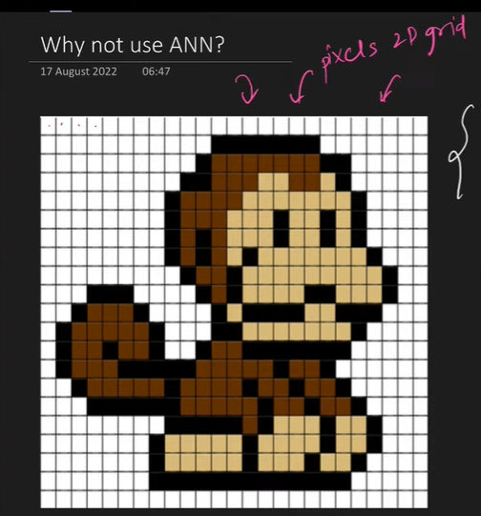
- High Computational Cost:
  - Image Structure: An image is essentially a 2D grid of pixels.
  - ANN Input Requirement: For an ANN, this 2D image must be flattened into a 1D array of numbers. For example, a 40x40 pixel image has 1600 pixels, which become 1600 numbers in a 1D array.
  - Weight Explosion: When these 1D pixels are connected to a fully connected hidden layer, the number of weights becomes extremely large.
    - Example: For a small 40x40 pixel image (1600 pixels) connected to a modest hidden layer with 100 units, the number of weights in just the first layer would be 1600 * 100 = 160,000 weights.
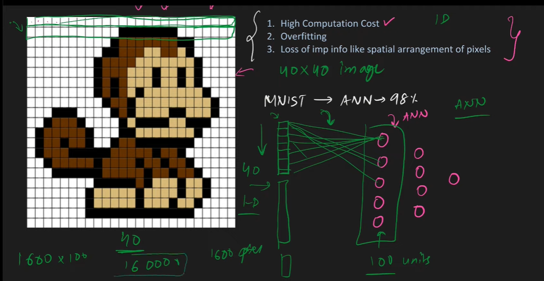
  - Consequence: As image sizes increase (e.g., 1000x1000 pixels) or the number of hidden units grows, the number of weights can reach millions or billions, leading to immense computational costs and significantly longer training times.
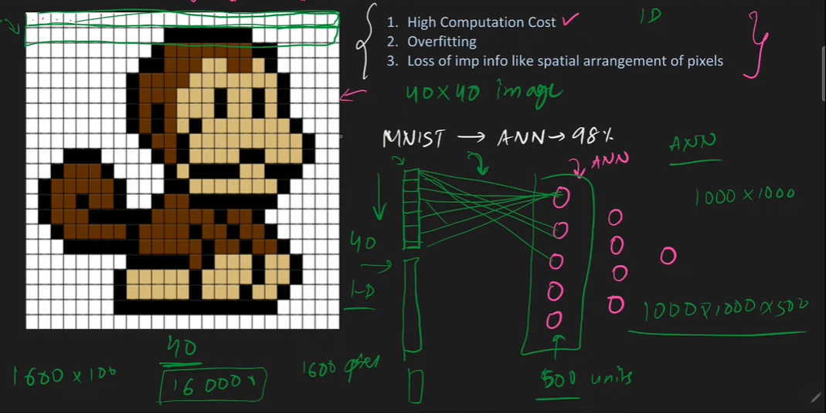
- Overfitting:
  - By connecting every single pixel to every node in the subsequent layer, an ANN attempts to learn and capture every minute pattern in the image, no matter how insignificant.
  - Consequence: This exhaustive learning often leads to overfitting, where the model performs exceptionally well on the training data but fails to generalize and performs poorly on new, unseen test data.
- Loss of Spatial Arrangement:
  - Crucial Features: The spatial arrangement and relationships between pixels (e.g., the distance and relative position of a monkey's eye and nose) are very important features for identifying objects in an image.
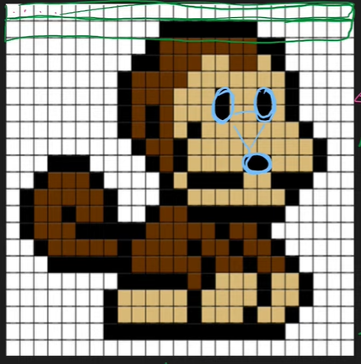
  - Flattening Issue: When a 2D image is converted into a 1D array for an ANN, this critical spatial context and arrangement are completely lost.
  - Consequence: The loss of these inherent 2D features severely hampers the ANN's ability to effectively classify images, leading to less accurate results compared to CNNs.

6. How CNNs Work: Intuition and Feature Extraction
CNNs approach image classification by mimicking how the human brain identifies objects.
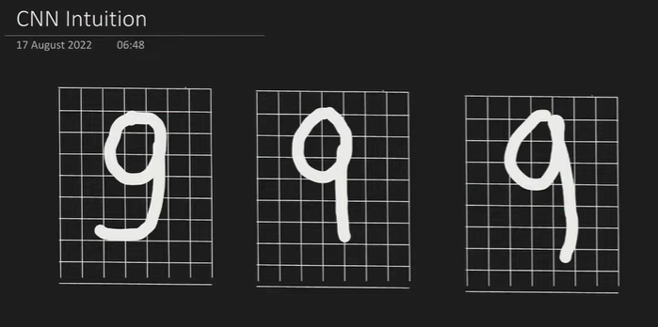
- Human Brain Analogy:
  - Consider classifying the digit '9'. Our brain doesn't just see a whole '9'; it looks for specific patterns: a circle, a vertical line, and a horizontal line.
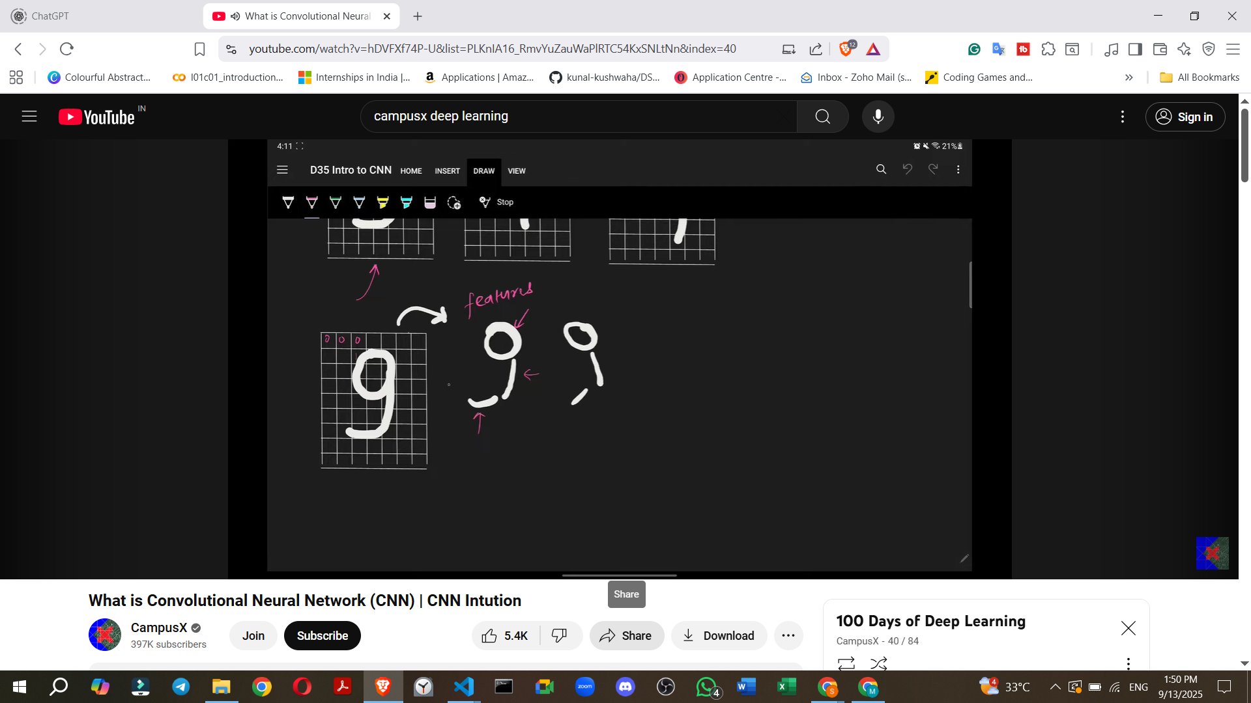
  - Even if these patterns are slightly distorted (e.g., a slightly imperfect circle or angled lines), our brain can still recognize the '9'.
  - This process involves breaking down the digit into its component features.
- CNN Mechanism:
  - Primitive Feature Extraction: When a CNN receives an image, its initial convolutional layers focus on extracting primitive features such as edges (horizontal, vertical, diagonal lines, corners).
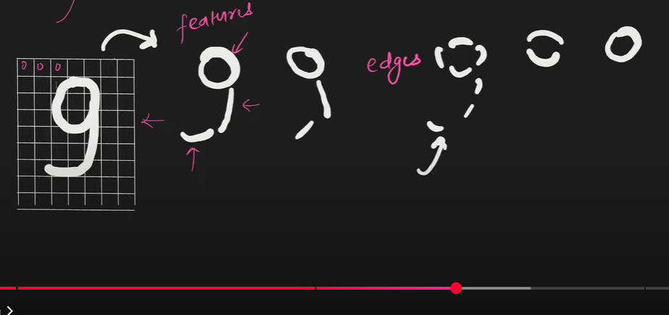
    - Example: For a '9', the CNN first identifies the basic edges that form the circle, the vertical stem, and the horizontal base.
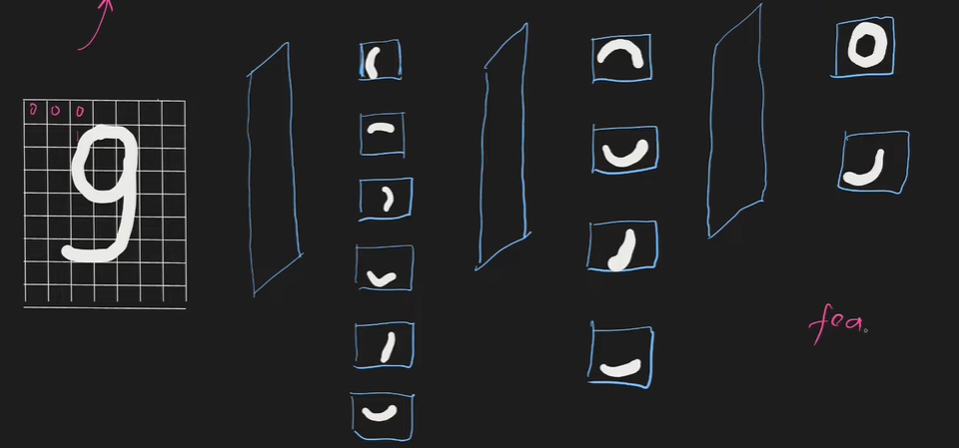
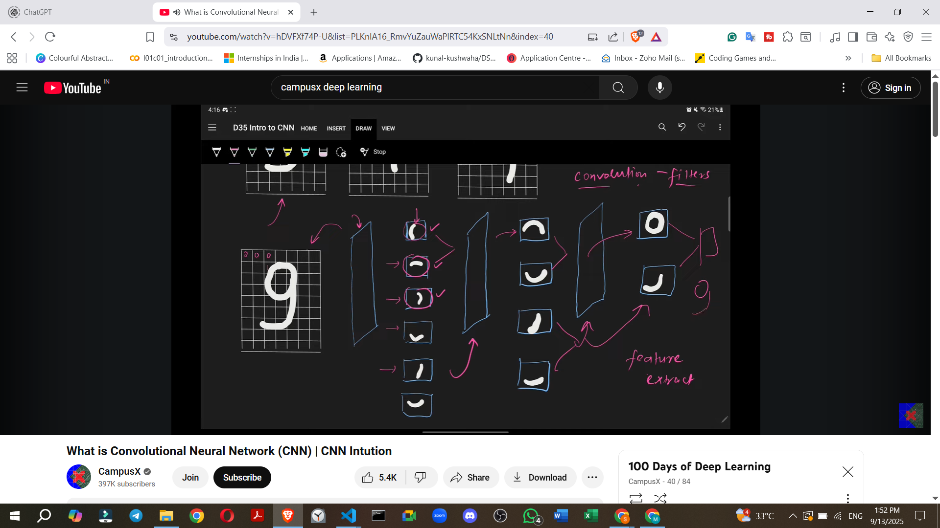
  - Filters/Kernels: Convolutional layers employ "filters" (also known as kernels). These are small matrices that "slide" or "move" across the input image.
    - The purpose of these filters is to detect specific patterns or features within the image.
    - When a filter matches a particular pattern (e.g., a vertical edge), that feature becomes "activated".
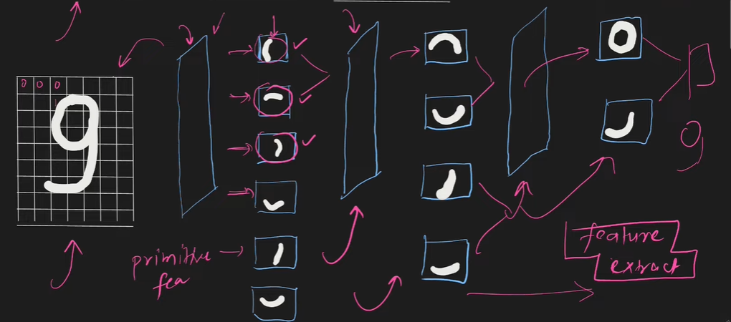
  - Building Complex Features:
    - The primitive features extracted by earlier layers are then passed to subsequent convolutional layers.
    - These deeper layers combine the simpler features to build more complex and meaningful features.
    - Example (Digit 9): Edges are combined to form semi-circles, which are then combined to form a full circle. Simultaneously, other edges are combined to form lines.
    - Example (Cat Image): Initial layers might detect simple edges. Middle layers would combine these edges to form more complex parts like ears, eyes, or a mouth. The deepest layers would then combine these parts to recognize a full face or body of a cat, allowing the CNN to classify the image as a "cat".
  - Deep Learning Principle: As the CNN gets progressively "deeper" (more layers), it extracts increasingly abstract and complex features, moving from primitive edges to high-level conceptual components, ultimately leading to accurate classification.

7. Applications of CNNs
CNNs are extremely popular and widely applied across a diverse range of problems:
- Image Classification: Categorizing a given image into one of several predefined classes.
  - Example: Determining if an image contains a cat or a dog, or identifying specific objects like a container ship, motor scooter, or leopard.
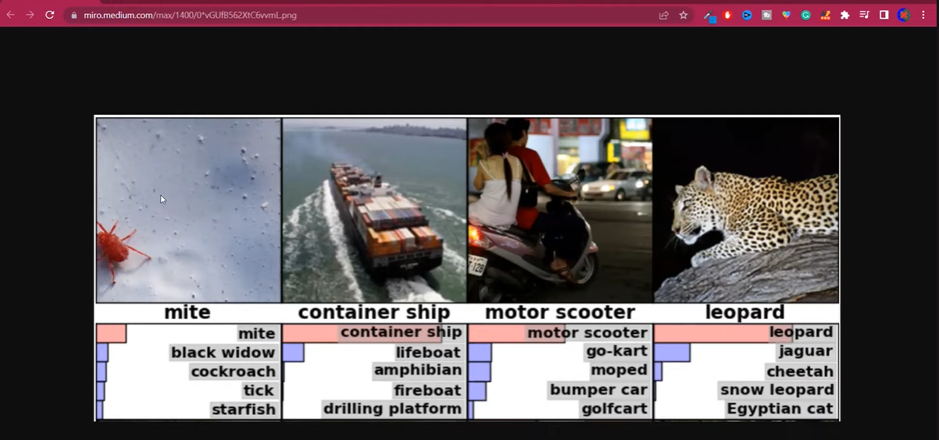
- Object Localisation: Identifying the presence and exact location of a specific object within an image by drawing a rectangular bounding box around it.
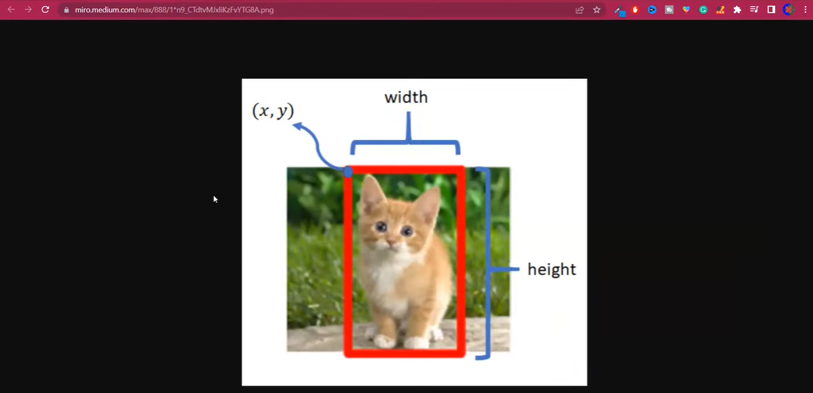
- Object Detection: A more complex task that involves identifying all objects within an image, locating them with bounding boxes, and also providing a probability score indicating the confidence of detection.
  - Example: Crucial for technologies like self-driving cars to detect pedestrians, other vehicles, and traffic signs.
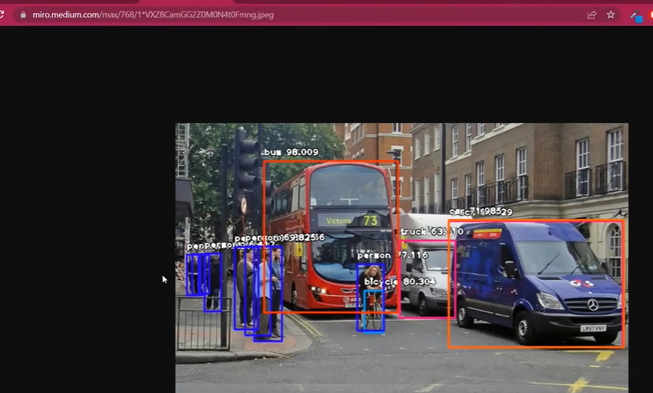
- Face Detection and Recognition:
  - Example: Used in modern smartphone cameras for unlocking devices or applying effects.
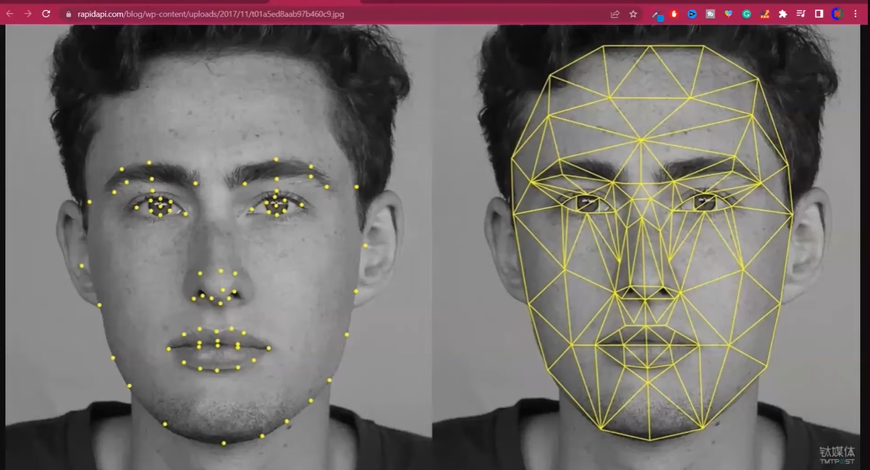
- Image Segmentation: Dividing an image into multiple segments or regions, often based on semantic meaning.
  - Example: Separating a tiger from its background in an image, useful for further image processing or analysis.
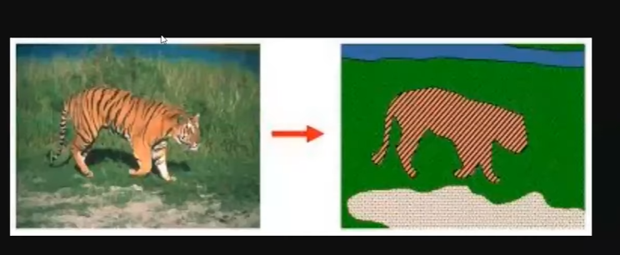
- Super-Resolution: Enhancing the quality and increasing the resolution of low-resolution images.

- Image Colorisation: Converting black-and-white photos or videos into color.
  - Example: Reviving old family photos or classic movies by adding color.

- Pose Estimation: Detecting the current pose of a human body from a camera feed.
  - Example: Used in fitness applications to track exercise movements (e.g., yoga poses) or in gaming consoles like Microsoft Kinect or PlayStation for interactive gameplay.
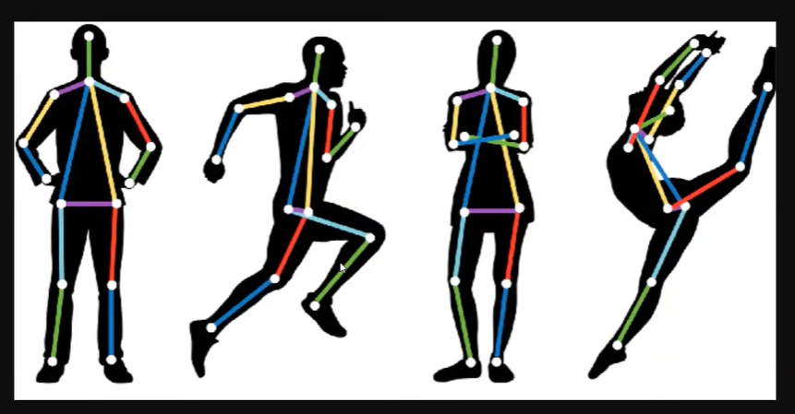

8. Speaker's Future Learning Plan for CNNs
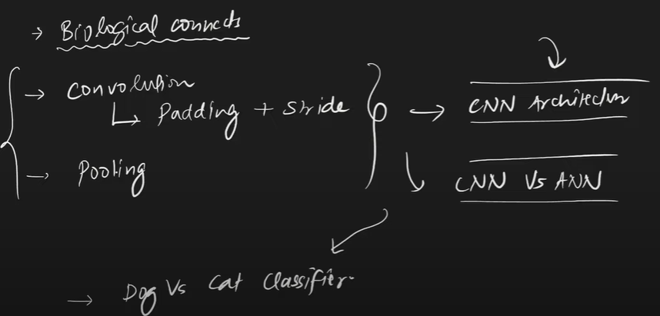
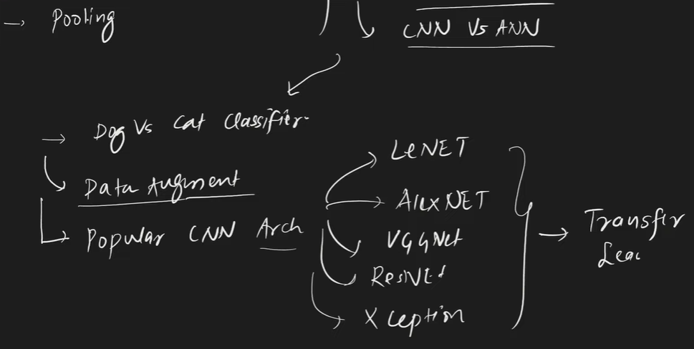
The speaker outlines a comprehensive plan for future videos to cover CNNs in detail:
- Biological Connection: A detailed exploration of how the human brain's visual system inspired CNN architecture.
- Core CNN Concepts:
  - Convolution Operation: In-depth explanation of how it works.
  - Padding: Understanding how padding is used in convolutional layers.
  - Strides: Detailed discussion on strides in convolution.
  - Pooling Layer: A thorough study of the pooling layer.
- Building CNN Architectures: How to construct a complete CNN model.
- CNN vs. ANN Comparison: Practical comparisons to highlight the performance differences.
- Practical Implementation:
  - Building a "Dog vs. Cat Classifier" using a real dataset of images.
  - Data Augmentation: A technique to expand datasets, especially useful when data is scarce.
- Popular CNN Architectures: Study of well-known and influential CNN models:
  - LeNet
  - AlexNet
  - VGGNet
  - ResNet
  - InceptionNet
- Transfer Learning: An important concept involving the use of pre-trained models.
- Further Projects: Object Detection will be covered after the speaker discusses Recurrent Neural Networks (RNNs).

